An Encounter with St. Thérèse of Lisieux
and her parents, Blessed Louis and Zélie Martin
Pray in the presence of their relics on Sunday, January 5, 2014
from 10:00 a.m. to 4:00 p.m.
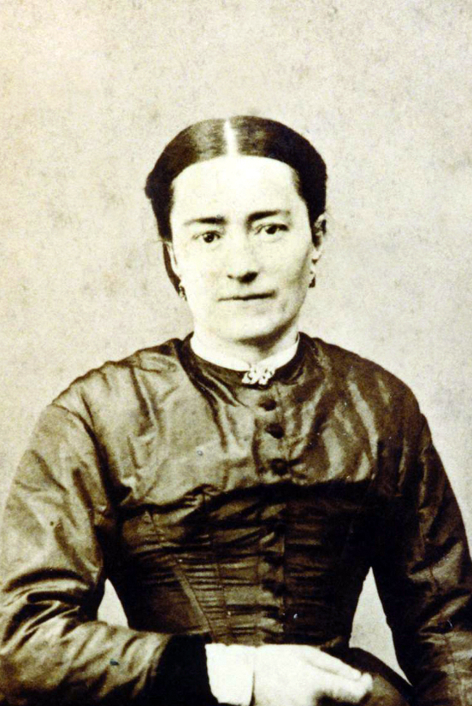
Blessed Zélie Martin about 1875
Photo credit: Madame F. Besnier
“The challenge of Christian motherhood:
Blessed Zélie Martin and the spiritual formation of children”
- a conference by Maureen O’Riordan at 1:00 p.m.
Benediction of the Most Blessed Sacrament at 3:30 p.m.
with a special blessing for mothers
Carmelite Monastery Bookstore open
1400 66th Avenue 10:00 a.m. to 3:30 p.m.
(66th Ave. and Broad Street) Spiritual books, children’s books, DVDs,
Philadelphia, Pa. religious articles. Cash and checks only.
Free parking in monastery lot
on 66th Avenue Chapel is handicapped-accessible.

