An Encounter with St. Thérèse of Lisieux
and her parents, Blessed Louis and Zélie Martin
Pray and adore the Eucharist on Sunday, December 7, 2014
from 10:00 a.m. to 4:00 p.m.
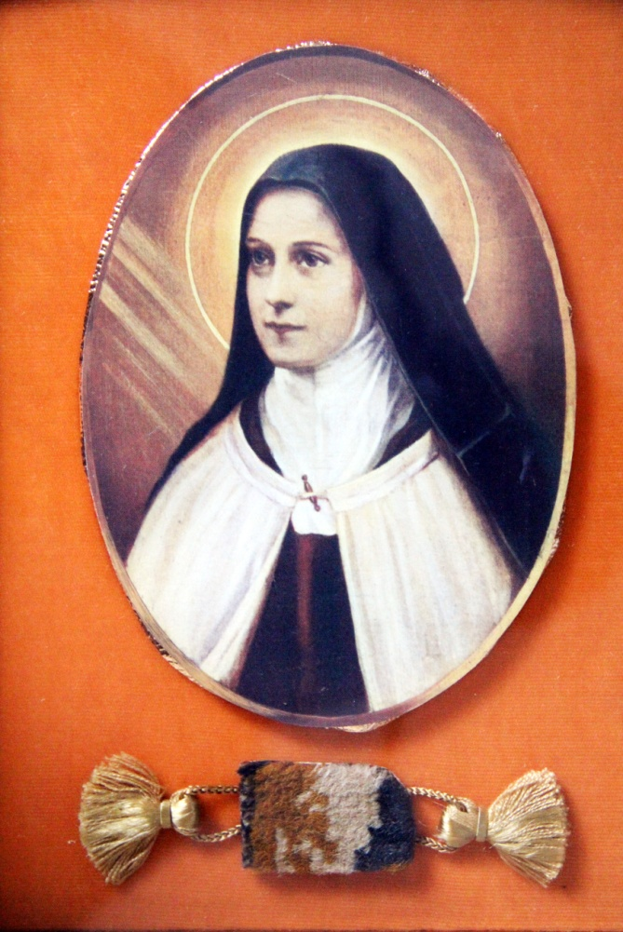
St. Therese; a fragment of the carpet used when she received the Habit
“Philadelphia as the Birthplace of Devotion
to St. Therese of Lisieux in the United States,
Part II: the Philadelphia Carmel’s
Relationship With the Lisieux Carmel”
- a conference by Maureen O’Riordan at 1:00 p.m.
Benediction of the Blessed Sacrament at 3:30 p.m.
Carmelite Monastery Bookstore open
1400 66th Avenue 10:00 a.m. to 3:30 p.m.
(66th Ave. and Broad Street) Spiritual books, children’s books, DVDs,
Philadelphia, Pa. religious articles. Buy Christmas gifts!
Free parking in monastery lot Cash and checks only.
on 66th Avenue Chapel is handicapped-accessible.

