An Encounter with St. Thérèse of Lisieux
and her parents, Blessed Louis and Zélie Martin
Pray in the presence of their relics on Sunday, September 7, 2014
from 10:00 a.m. to 4:00 p.m.
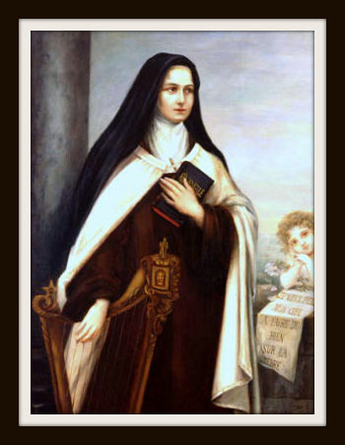
Portrait by St. Therese’s sister Celine (Sister Genevieve)
commissioned for the Philadelphia Carmel by Pauline Wilcox in 1907
“The Martin Family and the Carmel of Lisieux,
and St. Thérèse and the Carmel of Philadelphia,
the Birthplace of Devotion to Her in the United States”
- a conference by Maureen O’Riordan at 1:00 p.m.
Benediction of the Blessed Sacrament at 3:30 p.m.
Carmelite Monastery Bookstore open
1400 66th Avenue 10:00 a.m. to 3:30 p.m.
(66th Ave. and Broad Street) Spiritual books, children’s books, DVDs,
Philadelphia, Pa. religious articles. Cash and checks only. Free parking in monastery lot
on 66th Avenue Chapel is handicapped-accessible.
thereseoflisieux.org discalcedcarmelitesphila.org louisandzeliemartin.org

