An Encounter with
St. Thérèse of Lisieux
and her parents, Blessed Louis and Zélie Martin

Pray in the presence of their relics on Sunday, May 4, 2014
from 10:00 a.m. to 4:00 p.m.

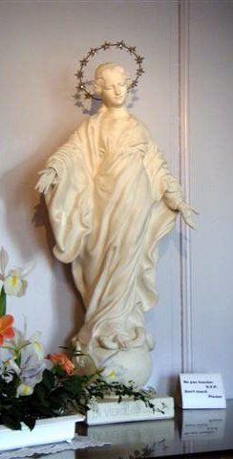
“More Mother than Queen: Mary in the Life and Spirituality of St. Thérèse of Lisieux and Her Family”
- a conference by Maureen O’Riordan at 1:00 p.m.
Benediction of the Blessed Sacrament at 3:30 p.m.
A replica of the statue of Mary before which St. Thérèse
and her sisters were praying when Thérèse was cured at the age of ten.

Carmelite Monastery Bookstore open
1400 66th Avenue 10:00 a.m. to 3:30 p.m.
(66th Ave. and Broad Street) Spiritual books, children’s books, DVDs,
Philadelphia, Pa. religious articles. Cash and checks only.
Free parking in monastery lot
on 66th Avenue Chapel is handicapped-accessible.
thereseoflisieux.org discalcedcarmelitesphila.org louisandzeliemartin.org

