An Encounter with St. Thérèse of Lisieux
and her parents, Blessed Louis and Zélie Martin
Pray in the presence of their relics on Sunday, March 2, 2014
from 10:00 a.m. to 4:00 p.m.
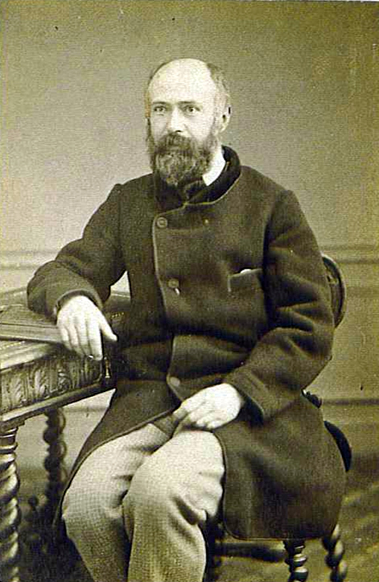
Louis Martin about 1863, aged about 40
“Blessed Louis Martin,
the ‘incomparable father’ of St. Thérèse of Lisieux:
how can he help Christian fathers today?”
- a conference by Maureen O’Riordan at 1:00 p.m.
Benediction of the Most Blessed Sacrament at 3:30 p.m.
with a special blessing for fathers, grandfathers, and godfathers
Carmelite Monastery Bookstore open
1400 66th Avenue 10:00 a.m. to 3:30 p.m.
(66th Ave. and Broad Street) Spiritual books, children’s books, DVDs,
Philadelphia, Pa. religious articles. Cash and checks only.
Free parking in monastery lot
on 66th Avenue Chapel is handicapped-accessible.
thereseoflisieux.org discalcedcarmelitesphila.org louisandzeliemartin.org

