An Encounter with St. Thérèse of Lisieux
and her parents, Blessed Louis and Zélie Martin
Pray in the presence of their relics on Sunday, August 3, 2014
from 10:00 a.m. to 4:00 p.m.
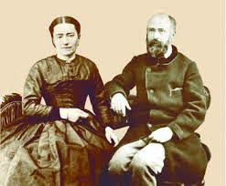
“Louis and Zélie Martin as Ministers of Charity and Justice:
Loving and Serving Christ in Our Neighbor and in the Poor”
- a conference by Maureen O’Riordan at 1:00 p.m.
Benediction of the Blessed Sacrament at 3:30 p.m.
Carmelite Monastery Bookstore open
1400 66th Avenue 10:00 a.m. to 3:30 p.m.
(66th Ave. and Broad Street) Spiritual books, children’s books, DVDs,
Philadelphia, Pa. religious articles. Cash and checks only. Free parking in monastery lot
on 66th Avenue Chapel is handicapped-accessible.
thereseoflisieux.org discalcedcarmelitesphila.org louisandzeliemartin.org

