An Encounter with St. Thérèse of Lisieux
and her parents, Blessed Louis and Zélie Martin
Pray in the presence of their relics on Sunday, February 2, 2014
from 10:00 a.m. to 4:00 p.m.
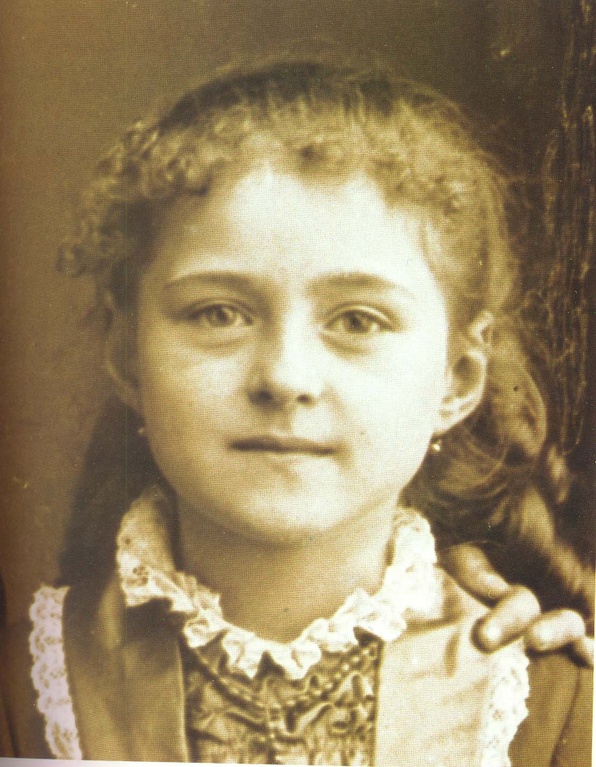
Thérèse Martin in 1881, age eight
Photo credit: M. Besnier, photographer at Lisieux
“The role of the child in the Martin family
and in the spirituality of St. Thérèse”
- a conference by Maureen O’Riordan at 1:00 p.m.
Benediction of the Most Blessed Sacrament at 3:30 p.m.
with a special blessing for those in consecrated life
Carmelite Monastery Bookstore open
1400 66th Avenue 10:00 a.m. to 3:30 p.m.
(66th Ave. and Broad Street) Spiritual books, children’s books, DVDs,
Philadelphia, Pa. religious articles. Cash and checks only.
Free parking in monastery lot
on 66th Avenue Chapel is handicapped-accessible.

