An Encounter with St. Thérèse of Lisieux
and her parents, Blessed Louis and Zélie Martin
Pray in the presence of their relics on Sunday, April 6, 2014
from 10:00 a.m. to 4:00 p.m.
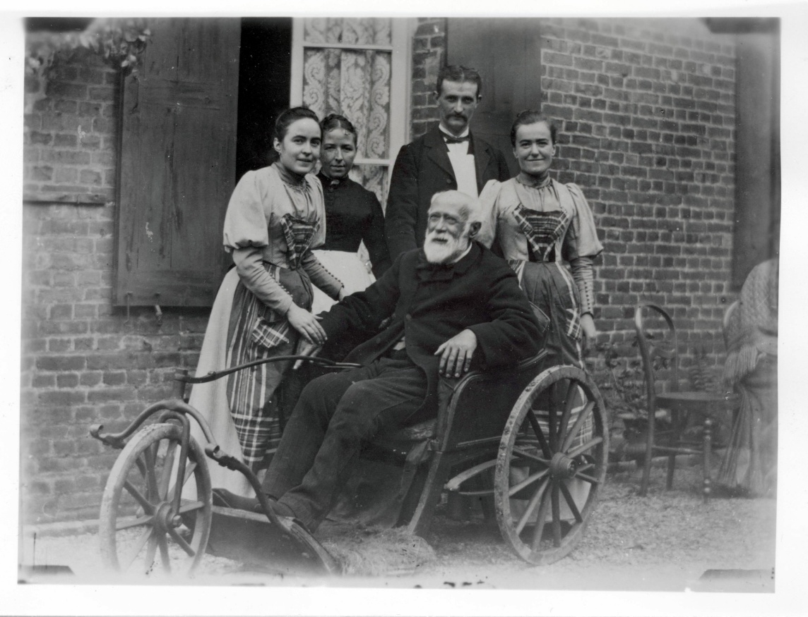
Blessed Louis Martin, age 68, in his wheelchair in 1892, with his daughters Céline and Léonie and servants.
“Sickness and Health in the Martin Family, and How
St. Thérèse and Her Blessed Parents Intercede for Healing”
- a conference by Maureen O’Riordan at 1:00 p.m.
Benediction of the Blessed Sacrament at 3:30 p.m.
with a special blessing for the sick and prayer for healing
Carmelite Monastery Bookstore open
1400 66th Avenue 10:00 a.m. to 3:30 p.m.
(66th Ave. and Broad Street) Spiritual books, children’s books, DVDs,
Philadelphia, Pa. religious articles. Cash and checks only.
Free parking in monastery lot
on 66th Avenue Chapel is handicapped-accessible.
thereseoflisieux.org discalcedcarmelitesphila.org louisandzeliemartin.org

